Our APP Landed!

KP’s patients need our help and we try our best to build app to transform patient to become physically active and having health habit.

today, we hlaunched the app for our patient. the app is focusing on motivation. in the app, there are various features : reward system, body test, Q&A.

this features push patient to become active and motivated to have healty life.

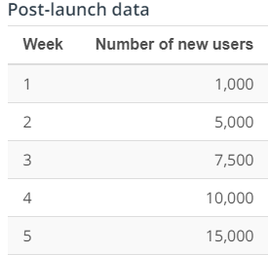

above is the post – launch data

we are successfully landed our app. only in 5 weeks there are 15,000 new users.

however there are some of the issue we have to figure out.

only 10% of our user give permission to notification. this is cruicial for us. because we have to notify user to keep in motivated. furthermore, user retention rate is low.

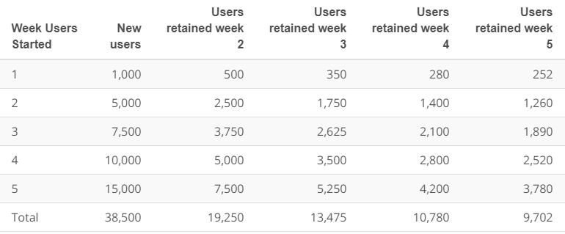

if you see the above data, new users are 38,500 and users retained are 9702.

only 20% of the user remain in our app.

so our next steps are below

1. figure a way to get more permission of notification from user
2. revise UI/UX to increase retaintino rate

Chae Wook Kim

thank you for all the effort you have been putting on this project.

on behalf of all my engineer and QA and design team member, i really appreciated